**Where to find more information about Kindergarten in Everett Public Schools**

District web site: <http://www.everett.k12.wa.us/everett>

Click on the Parents tab

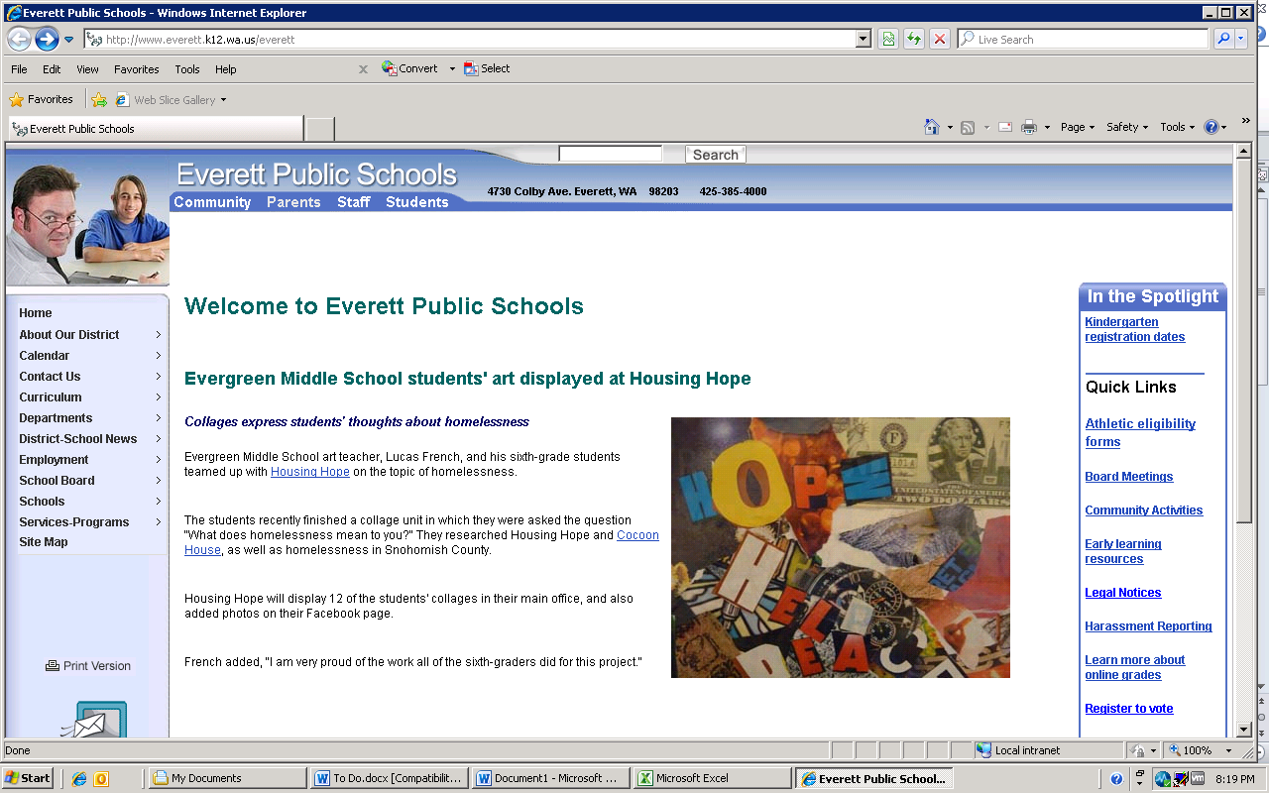

Under the Parents tab, select Kindergarten

The Kindergarten tab has three major parts:

* School and Path Finder (to identify your neighborhood school, bus option, etc.)
* 7 information links (enrollment check list, join District email, etc.)
* 8 registration forms (prior school experience, home language, etc.)